MicroHOWTO: Extract .deb packages from “tarball”

This tutorial illustrates how to extract .deb packages from a “tarball”. It presumes that you have already downloaded a suitable “tarball” to your Download folder.
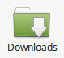

In this case we shall be extracting the .deb packages from the following "tarball":
LibreOffice_5.0.1_Linux_x86-64_deb.tar.gz
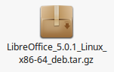

------------------------------------------------------------------------------------------------------------------------
What is a tarball?
A "tarball" is a special type of file that serves as an archive. It is actually a collection of folders and files that are packaged together under one file name (that's what .tar signifies), and makes downloading easier.
In this case the file is also compressed for quicker downloads; identified by the .gz part of the file name.
Note: gzip (GNU zip) produces files with a .gz extension.
------------------------------------------------------------------------------------------------------------------------
Instructions

1). Right-click on your “tarball”.

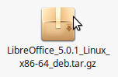

2). Select Open With Archive Manager from the drop down menu.

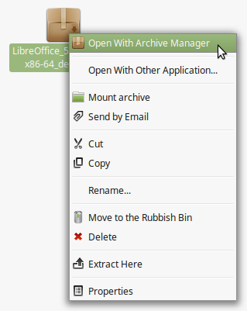

3). Left-click on the Save File button when the Opening LibreOffice_5.0.1_x86-64.tar.gz pop-up window opens up

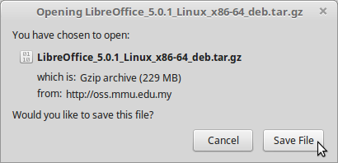

4). Another pop-up window (LibreOffice_5.0.1_Linux_x86-64_deb.tar.gz) opens up.

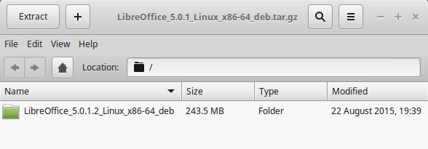
5). At this point you can either:

- Left-Click anywhere next to the green folder

and then left-click on the Extract button

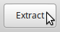

or:

- Right click anywhere next to the green folder and select Extract from the drop-down menu.
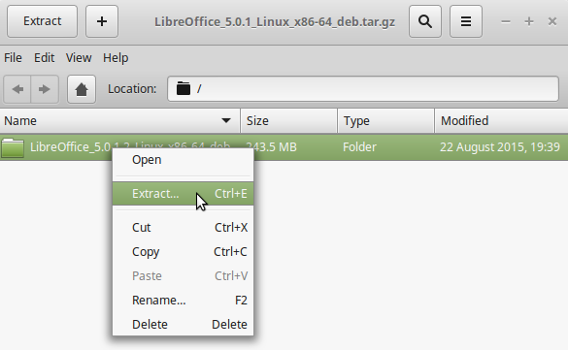

6). Another pop-up window called Extract opens up. Left-click on the Extract button (bottom right hand corner)
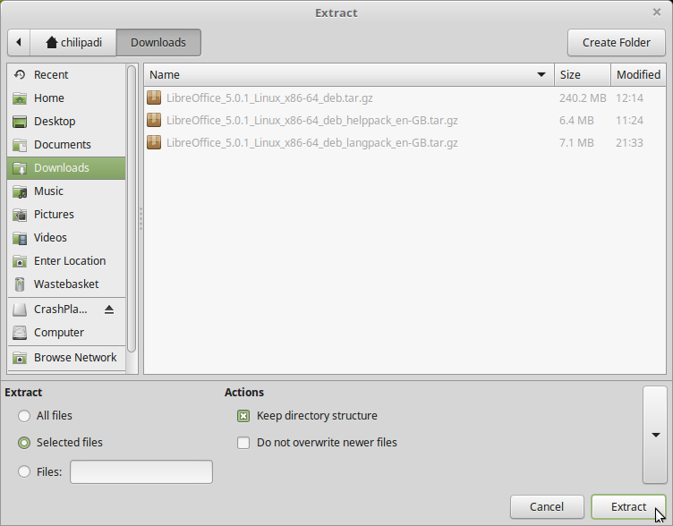

7). An Archive Manager pop-up window will open up, informing you that Extraction completed successfully.

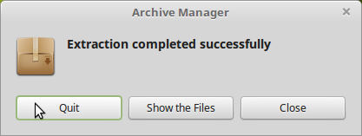

8). Left-click on the Quit button and head across to your Downloads folder.

9). Alongside your original “tarball” in your Downloads folder you should now have a green folder called LibreOffice_5.0.1.2_Linux_x86-64_deb which contains your extracted .deb packages.

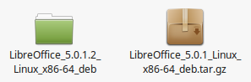

10). It is safe at this point to delete the original “tarball” if you wish.

------------------------------------------------------------------------------------------------------------------------
References
- Installing LibreOffice on Linux

https://wiki.documentfoundation.org/Documentation/Install/Linux

- How to install LibreOffice 5.0 on Linux Mint, Ubuntu, Xubuntu, Debian (by Johannes Eva)

http://www.libre-software.net/how-to-install-libreoffice-on-ubuntu-linux-mint

